Hidden Layer Block (Block 2) is a main module for this project. It constructs the structure of the neural network with 10 input neurons, 5 hidden neurons and 3 output neurons. Figure 1 shows the example neural network with 3 input neurons, 4 hidden neurons and 2 output neurons. In this project, the neural network is designed as **feedforward network.** Each unit receives inputs from the units to its left and the inputs are multiplied by the weight of the connections they travel along. Every unit adds up all the inputs it receives and the sum will performed an activation function (1). The result of activation function will give either 0/1 value which is used to “fire” and trigger the units it’s connected on its right.

$f\left(x\right)=0.5(\frac{x}{\left(1+\left|x\right|\right)}+1)$_______________________ (1)

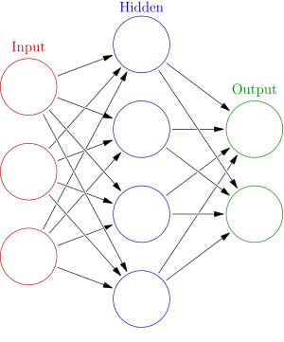

Figure 1: Example neural network

The data that get from image capture will be a 10 by 10 matrix data. For this neural network, each input neuron consists of 10 bits data therefore there are 10 input neurons. The concept of neural network is